**Topic:** Thales of Miletus

**Notes on Topic:** Around 600BC on the western coast of Asia Minor, in a town called Miletus lived the great Thales, of the so-called “Seven Wise Men”

*Seven Wise Men: Pittacus of Mytilene, and Bias of Priene, and our own Solon, and Cleobulus of Lindus, and Myson of Chenae, and the seventh of them was said to be Chilon of Sparta*

He is known for being the father of demonstrative mathematics, diving into the “why” along with the “how”, thus he is considered the earliest known mathematician

Thales was a mathematician and an astronomer who somehow predicted the solar eclipse in 585 BC, known for “know thyself”

He is known for being absent minded, according to legend, he was once strolling about, gazing at the stars and tumbled into an open well

Thales is also remembered for being unkind to men and animals, not in an outwardly abusive type of way, but in an insensitive way.

His insistence that geometric statements not be accepted based on their intuitive plausibility, but rather they needed subjecting to rigorous, logical proofs, gave him his reputation in mathematics

Thales was the first to prove, - vertical angles are equal - the angle sum of a triangle equals two right angles - the base angles of an isosceles triangle are equal - an angle inscribed in a semi-circle is a right angle

There is no record of Thale’s proof for any statement above, but in Elements III.31, Euclid’s proof of the last statements is simple and direct enough it is speculated that it may be Thales’ own **insert proof of statement**

Activity: try and prove one of the above statements in the simple and direct Thales method. There were no such thing as angle measurements such as degrees, nor were there any axioms of geometry, have a group participation and discussion.

**In Course Examples:** Euclid’s proof of inscribed angles in a semi-circle is a right angle

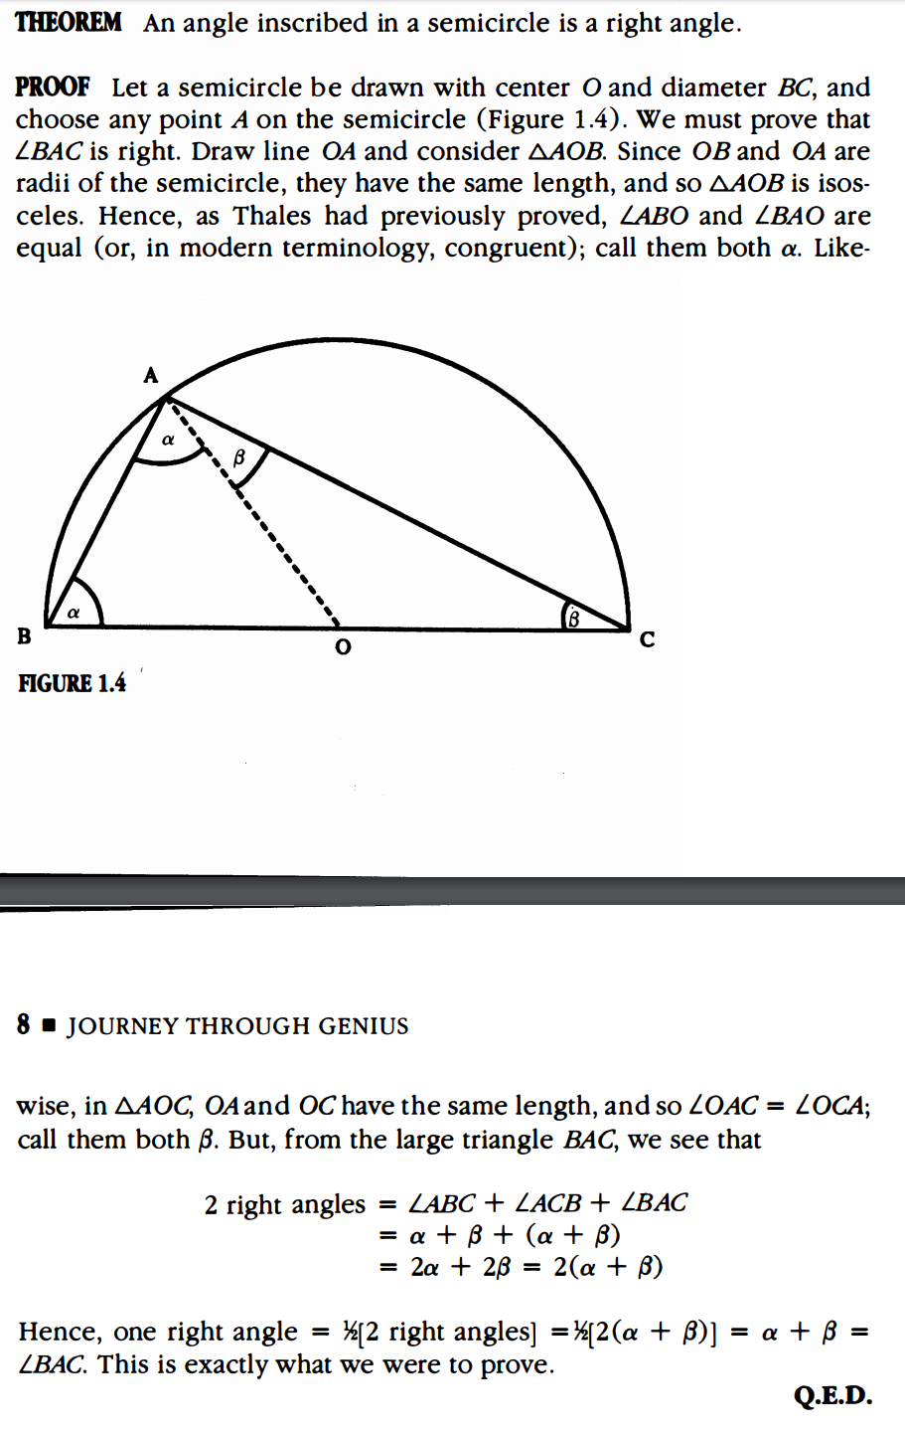

**Additional Suggested Reading**: N/A

**Assignment:** No assigned problems